**MEDIA RELEASE**

*For immediate release* October 2019

Jesse and Mel’s hidden advantage on The Block

Jesse and Mel’s chances of winning The Block may have increased slightly after their property was shown to hold nearly $3.68 million in tax deductions for the future buyer should they decide to rent the property out. This attribute could increase the price that property investors are willing to pay for the property and give the pair an edge during the final auction.

The Australian Taxation Office allows owners of income producing properties to claim deductions for the wear and tear that occurs as a building gets older and items within it wear out. Each property is unique and holds different depreciation benefits.

BMT Tax Depreciation has worked with more than half a million Australian property investors to help uncover these lucrative tax deductions and recently assessed The Block apartments for their hidden depreciation values.

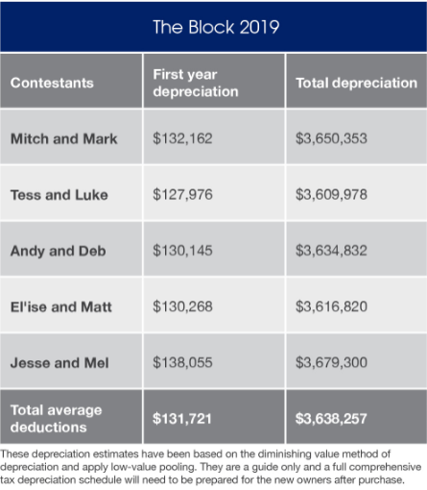

The CEO of BMT, Bradley Beer said that while Jesse and Mel had a slight edge when it came to tax deductions, the field was very close this year.

“Smart property investors will often make note of the depreciation potential of properties and use that data to help inform the offers they make.

“While Jesse and Mel’s property holds the most total deductions, Mitch and Mark ($3.65 million) and Andy and Deb ($3.63 million) are hot on their heels.”

The BMT assessment showed that Tess and Luke had the property with the lowest amount of tax deductions ($3.61 million) followed by El’ise and Matt ($3.62 million).

Jesse and Mel’s property also held the largest amount of deductions ($138,055) claimable in the first year of ownership. This again would be of interest to property investors that are looking to maximise the return from any property investment.

The average Block property contained $131,721 in first year deductions.

“With many challenging real estate markets in Australia at present, cash flow will be a key objective for investors and this is where tax depreciation plays a large role,” said Bradley Beer.

“Buyers looking to bid on the show and buyers in real estate markets across Australia, can make more informed decisions by understanding the depreciation values of properties and how those values will impact their cash flow,” said Bradley Beer.

BMT Tax Depreciation has been working with The Block to provide depreciation assessments for more than ten years. Property Investors interested in better understanding the tax deductions that could be available to them can utilise BMT’s free online tax depreciation calculator at   
[bmtqs.com.au/tax-depreciation-calculator](https://www.bmtqs.com.au/tax-depreciation-calculator)

**- ENDS –**

**For all media enquires please contact:**  
Bradley Beer   
CEO, BMT Tax Depreciation   
  
Phone: 0413 271 777   
Email: [media@](mailto:media@)bmtqs.com.au

**About BMT Tax Depreciation**

BMT Tax Depreciation (BMT) is a Quantity Surveying company specialising in the provision of tax depreciation schedules for residential and commercial investment properties. Commencing business in 1997, demand from property investors nationally has seen business expand Australia-wide with offices now located in Sydney, Parramatta, Melbourne, Brisbane, Newcastle, Adelaide, Perth, Gold Coast, Cairns, Canberra, Hobart and Darwin.